Descriptive Analysis of COTS Population Structure

Ela Jeen M. Gonesto

## Load Data

cots_data <- data.frame(  
 Total_Body_Weight = c(860, 820, 680, 700, 300, 400, 620, 660, 240, 320, 280, 680, 760, 410, 730, 880, 560, 780, 940, 440, 570, 500, 360, 580, 400, 500, 440, 340, 680, 330, 490, 560, 440, 420, 1140, 1070, 520, 440, 780),  
 Diameter = c(32, 33, 27, 30, 23, 25, 27, 26, 22, 25, 21, 26, 34, 25, 32, 34, 28, 32, 32, 25, 28, 25, 24, 26, 22, 29, 27, 21, 32, 23, 25, 27, 25, 24, 40, 36, 28, 29.5, 31),  
 Number_of_Arms = c(15, 13, 13, 14, 14, 10, 14, 14, 14, 15, 14, 15, 13, 13, 14, 14, 14, 14, 15, 13, 14, 12, 15, 14, 15, 12, 14, 15, 14, 15, 13, 15, 13, 14, 13, 15, 12, 15, 15)  
)

## Summary Statistics

summary_stats <- cots_data %>%  
 summarise(  
 Mean_Weight = mean(Total_Body_Weight),  
 Median_Weight = median(Total_Body_Weight),  
 SD_Weight = sd(Total_Body_Weight),  
 Min_Weight = min(Total_Body_Weight),  
 Max_Weight = max(Total_Body_Weight),  
   
 Mean_Diameter = mean(Diameter),  
 Median_Diameter = median(Diameter),  
 SD_Diameter = sd(Diameter),  
 Min_Diameter = min(Diameter),  
 Max_Diameter = max(Diameter),  
   
 Mode_Arms = as.numeric(names(sort(table(Number_of_Arms), decreasing = TRUE)[1]))  
 )  
print(summary_stats)

Mean_Weight Median_Weight SD_Weight Min_Weight Max_Weight Mean_Diameter  
1 580 560 220.0359 240 1140 27.73077  
 Median_Diameter SD_Diameter Min_Diameter Max_Diameter Mode_Arms  
1 27 4.381249 21 40 14

## Distribution Analysis

hist(cots_data$Total_Body_Weight, main="Distribution of Total Body Weight", xlab="Weight (g)", col="lightblue", breaks=10)

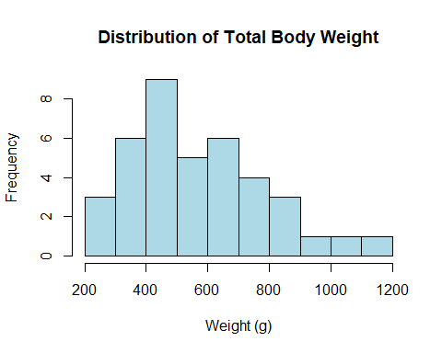

hist(cots_data$Diameter, main="Distribution of Diameter", xlab="Diameter (cm)", col="lightgreen", breaks=10)

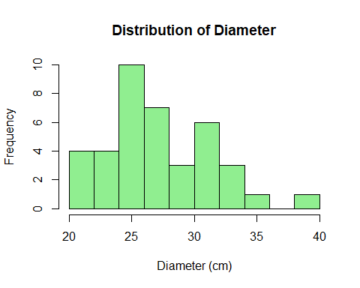

## Outlier Detection

boxplot(cots_data$Total_Body_Weight, main="Boxplot of Total Body Weight", col="lightblue")

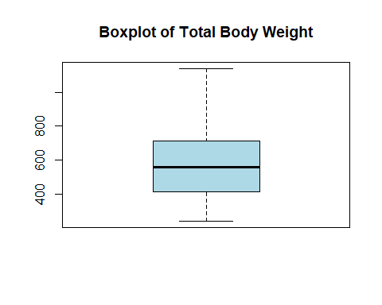

boxplot(cots_data$Diameter, main="Boxplot of Diameter", col="lightgreen")

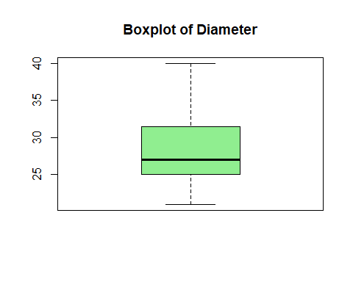

## Correlation Analysis

cor_matrix <- cor(cots_data[, c("Total_Body_Weight", "Diameter", "Number_of_Arms")])  
print(cor_matrix)

Total_Body_Weight Diameter Number_of_Arms  
Total_Body_Weight 1.00000000 0.91556251 0.07951378  
Diameter 0.91556251 1.00000000 -0.01681194  
Number_of_Arms 0.07951378 -0.01681194 1.00000000

## Scatterplot

ggplot(cots_data, aes(x = Diameter, y = Total_Body_Weight)) +  
 geom_point(color = "blue") +  
 geom_smooth(method = "lm", color = "red", se = FALSE) +  
 labs(title = "Scatterplot of Diameter vs. Total Body Weight", x = "Diameter (cm)", y = "Total Body Weight (g)")

`geom_smooth()` using formula = 'y ~ x'

